HeadShop 11 PRD (Preliminary)

Budget: $1,200

Milestone 1. Main Task ($1,000)

Goal: Using the Luxand SDK develop a method of capturing faces that are somewhat turned from straight-on (3/4 profile, also turned slightly up and down).

In order to do this we need to enable the 3D head full rotation on all three axes. The following steps are not necessarily visible to the user (can work at the setup)

Step 1: Image is loaded and point established (same as OneClick)

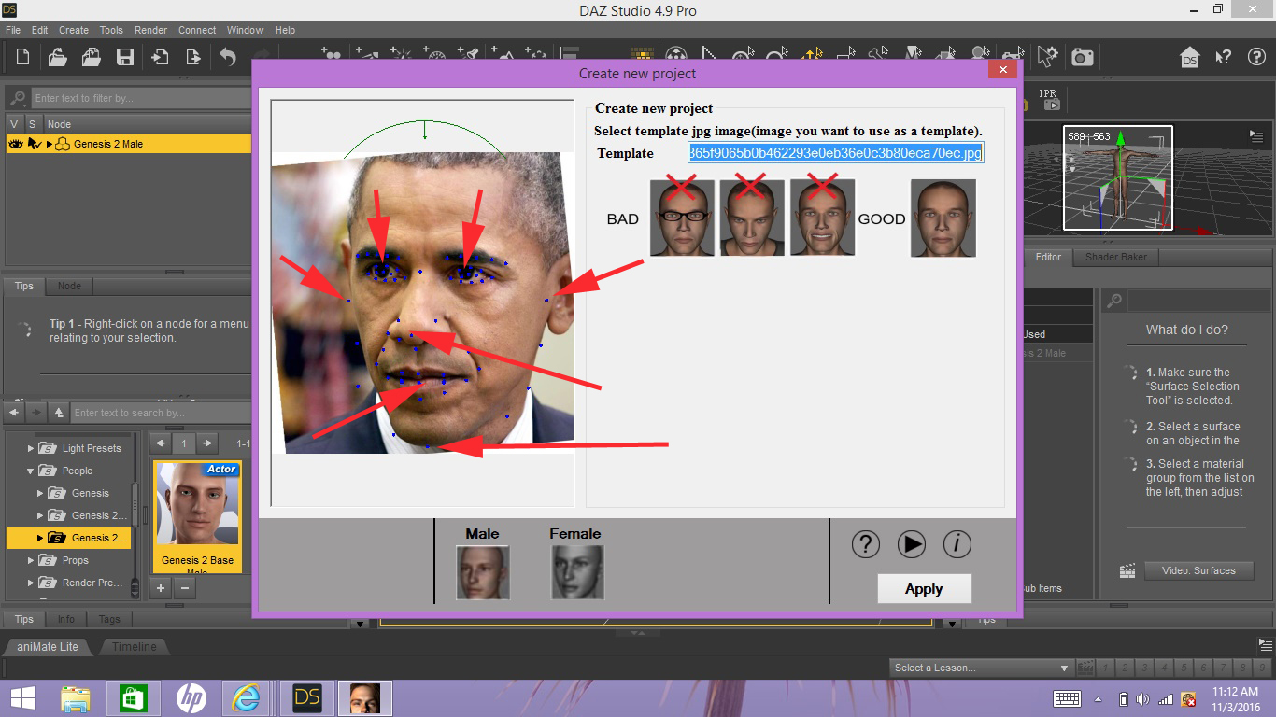

Step 2. Based on some of the captured points (left and right eye, middle of the mouth, top left and right cheek, etc) the 3D head is turned to mimic the rotation of the picture.

NOTE: Please watch video of an old Abalone software that did the same manually.

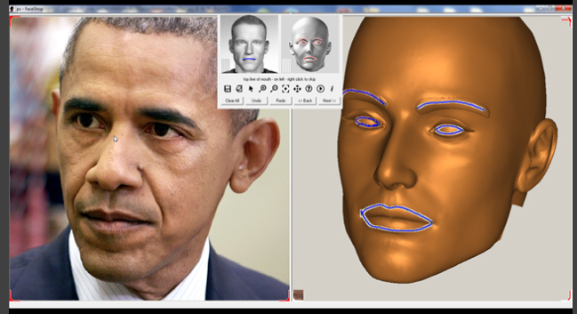

Step 2. Once head is turned properly, the software maps texture.

Step 3. The texture map needs to use the “mirror” function of the earlier HeadShop versions to mirror the good side of the texture to the other. This may be difficult to achieve,

Step 4. Once texture is mirrored, application deforms the shape according to the outlines provided by the SDK.

Step 5. User is presented with the proper 3D head (same as current).